Supply Chain Delivery Risk Analysis Report

1. Executive Summary
This report presents an end-to-end analysis of supply chain delivery delays using SQL, Python, and Power BI. The objective was to identify structural drivers of delivery risk and quantify their operational impact. Analysis shows that approximately 57% of all orders are delivered late, indicating a systemic fulfillment issue. Shipping mode is identified as the dominant risk driver, with First Class shipments violating SLA expectations consistently. Based on these findings, the report recommends revisiting SLA definitions and realigning shipping mode usage to improve delivery reliability.

2. Business Problem & Objectives
Delivery delays directly impact customer satisfaction, operational cost, and service-level compliance. Despite multiple shipping options, delays persist across regions and time periods, suggesting deeper operational inefficiencies.
Objectives of this analysis:
- Identify the primary drivers of delivery delays
- Quantify delay risk and delayed order impact
- Evaluate whether delays are seasonal or structural
- Translate analytical findings into actionable business recommendations

3. Data Overview & Analytical Scope
The analysis is based on a large-scale order fulfillment dataset containing approximately 180,000 orders across multiple regions and years. The dataset includes order lifecycle timestamps, shipping modes, and delay indicators.
Key data attributes used:
- Order Date and Shipping Date
- Shipping Mode
- Scheduled vs Actual Delivery Days
- Delay Indicator and Delay Duration
- Order Region
The dataset provides sufficient granularity to support both operational and strategic analysis.

4. Data Preparation & Engineering (Python)
Python was used for data ingestion, cleaning, feature engineering, and validation.
Key steps performed in Python:
- Imported raw CSV data using pandas
- Converted order and shipping dates into proper datetime formats
- Engineered delivery delay metrics, including:
  - Delay duration (actual vs scheduled delivery days)
  - Binary delay indicator (is_delayed)
- Validated data quality and consistency across all records
Python enabled reproducible preprocessing and ensured analytical accuracy before downstream analysis.

5. Analytical Modeling & Aggregation (SQL)
SQL was used to structure the dataset into an analytical model and compute core business metrics.
Key SQL operations included:
- Creation of a centralized fact table containing order-level metrics
- Aggregation of delivery delays by shipping mode and region
- Computation of KPIs such as:
  - Total Orders
  - Delayed Orders
  - Delay Percentage
- Multi-level grouping to support rate-based and volume-based analysis
Using SQL ensured scalable aggregation logic aligned with real-world BI workflows.

6. Key Performance Indicators (KPIs)
The following KPIs were defined and validated using SQL and Python outputs:
- Total Orders: Total number of fulfilled orders
- Delayed Orders: Orders delivered later than scheduled
- Overall Delay Percentage: Ratio of delayed orders to total orders
These KPIs establish a quantitative foundation for performance evaluation.
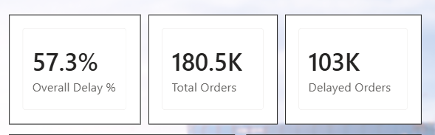
Figure 1: Key Delivery Performance Indicators

7. Primary Risk Driver Analysis (Power BI)
Visualization and insight communication were performed using Power BI.
Analysis of delay rates by shipping mode shows that shipping mode is the dominant determinant of delivery risk. First Class shipments demonstrate a 100% delay rate, while Second Class also exhibits elevated risk. Standard Class performs significantly better, indicating higher operational predictability.
This confirms that delivery delays are driven primarily by process and fulfillment design rather than geography.
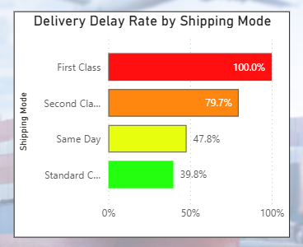
Figure 2: Delivery Delay Rate by Shipping Mode

8. Impact & Severity Analysis
Beyond delay rates, the analysis evaluates business impact and severity:
- High-volume shipping modes contribute the majority of delayed orders
- Delay trends remain consistent over time, indicating a structural issue
- Most delays are short in duration, but a non-trivial long tail of severe delays exists
This layered analysis enables prioritization based on both frequency and impact.
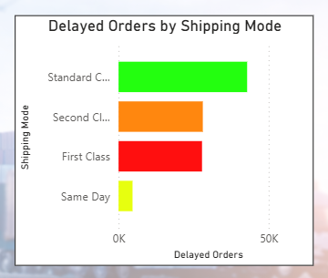
Figure 3: Contribution to Total Delayed Orders by Shipping Mode

9. Key Insights & Business Recommendations
Key Insights
- Approximately 57% of total orders are delivered late
- Shipping mode is the primary driver of delivery risk
- First Class shipments consistently violate SLA expectations
- Standard Class provides the most stable delivery performance
Business Recommendations
- Redefine SLA commitments for high-risk shipping modes
- Shift predictable demand toward Standard Class shipping
- Investigate operational bottlenecks affecting First Class fulfillment
- Use delay severity insights to prioritize corrective actions
9.1 Delay Trend Analysis :
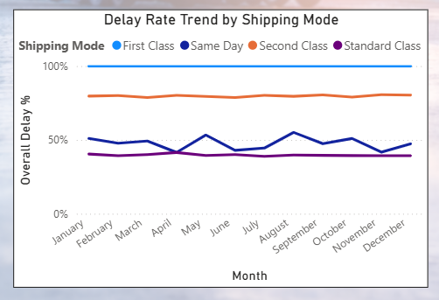
Figure 4: Delay Rate Trend Over Time by Shipping Mode

9.2 Delay Severity Analysis:

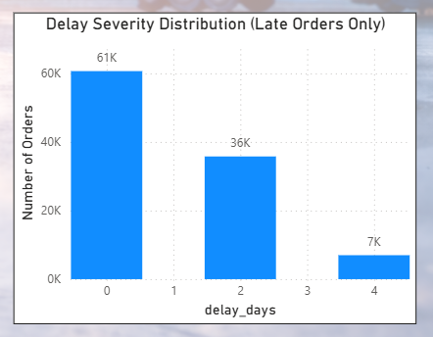
Figure 5: Delay Severity Distribution of Late Orders

10. Conclusion
This project demonstrates a complete analytics workflow combining Python for data preparation, SQL for analytical modeling, and Power BI for insight delivery. The findings reveal systemic delivery inefficiencies driven by shipping mode design rather than seasonal or regional factors. Implementing the recommended actions can significantly reduce delivery risk and improve supply chain reliability.

